START

1. Initialize the leaf node scores.

2. Calculate the height of the game tree.

3. Call the Minimax function from the root node.

4. Check whether the current node is a leaf node.
If yes, return its score.

5. If it is MAX player's turn:
Find the values of left and right children.
Select the maximum value.

6. If it is MIN player's turn:
Find the values of left and right children.
Select the minimum value.

7. Continue until the root node is reached.

8. Display the optimal value.

STOP

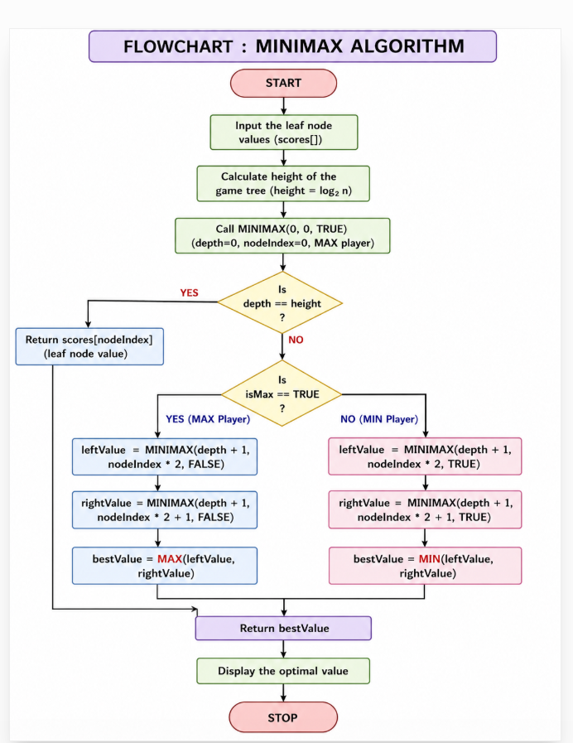

PSEUDOCODE: ALPHA-BETA PRUNING

1. Start the program.
2. Initialize the leaf node scores of the game tree.
3. Calculate the height of the game tree.
4. Set the initial Alpha value to -∞ and Beta value to +∞.
5. Start the Alpha-Beta search from the root node.
6. Check whether the current node is a leaf node.
If yes, return its score.
7. If the current player is MAX:
a. Find the values of its child nodes.
b. Select the maximum value.
c. Update Alpha with the maximum value.
8. If the current player is MIN:
a. Find the values of its child nodes.
b. Select the minimum value.
c. Update Beta with the minimum value.
9. After updating Alpha and Beta, check:
If Beta ≤ Alpha, stop checking the remaining branches.
This is called pruning.
10. Continue the process until the root node gets the best value.
11. Display the optimal value.
12. Stop the program.

